SORU 1:

Imports System.IO

Public Class Form1

Private Sub btnHesapla_Click(sender As Object, e As EventArgs) Handles btnHesapla.Click

If txtAdet.Text = "" Or txtBirimFiyat.Text = "" Or txtUrunAd.Text = "" Then

MsgBox("İlgili alanları doldurunuz !")

Return

End If

Dim dosya As New StreamWriter("KDV.txt")

Dim kdvDurum As String = "dahil degil"

If chKdv.Checked Then

kdvDurum = "dahil"

End If

dosya.WriteLine(txtUrunAd.Text + "," + txtBirimFiyat.Text + "," + txtAdet.Text + "," + kdvDurum)

dosya.Close()

MsgBox("Kaydedildi.")

End Sub

End Class

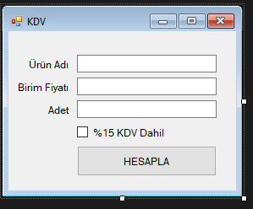

**SORU2:**

Imports System.IO

Public Class Form1

Dim ogrenciNo As String = ""

Dim secilenIndex As Integer = -1

Private Sub Listele()

lstVeri.Items.Clear()

Dim dosyaAdi As String = "ogrenci.txt"

For Each satir As String In File.ReadLines(dosyaAdi)

Dim veri = satir.Split(",")

Dim veriler As New ListViewItem

veriler.Text = veri(0)

veriler.SubItems.Add(veri(1))

veriler.SubItems.Add(veri(2))

lstVeri.Items.Add(veriler)

Next satir

End Sub

Private Sub Yazdir()

File.CreateText("ogrenci.txt").Close()

Dim dosya As New StreamWriter("ogrenci.txt")

For index = 0 To lstVeri.Items.Count - 1

Dim satir As String = lstVeri.Items(index).SubItems(0).Text + "," + lstVeri.Items(index).SubItems(1).Text + "," + lstVeri.Items(index).SubItems(2).Text

dosya.WriteLine(satir)

Next

dosya.Close()

ogrenciNo = ""

txtOgrenciNo.Text = ""

txtAd.Text = ""

txtSoyad.Text = ""

secilenIndex = -1

Listele()

End Sub

Private Sub Form1_Load(sender As Object, e As EventArgs) Handles MyBase.Load

Listele()

End Sub

Private Sub lstVeri_DoubleClick(sender As Object, e As EventArgs) Handles lstVeri.DoubleClick

txtOgrenciNo.Text = lstVeri.Items(lstVeri.SelectedIndices(0)).SubItems(0).Text

txtAd.Text = lstVeri.Items(lstVeri.SelectedIndices(0)).SubItems(1).Text

txtSoyad.Text = lstVeri.Items(lstVeri.SelectedIndices(0)).SubItems(2).Text

ogrenciNo = txtOgrenciNo.Text

secilenIndex = lstVeri.SelectedIndices(0)

End Sub

Private Sub btnKaydet_Click(sender As Object, e As EventArgs) Handles btnKaydet.Click

Dim veriler As New ListViewItem

veriler.Text = txtOgrenciNo.Text

veriler.SubItems.Add(txtAd.Text)

veriler.SubItems.Add(txtSoyad.Text)

lstVeri.Items.Add(veriler)

Yazdir()

End Sub

Private Sub btnGuncelle_Click(sender As Object, e As EventArgs) Handles btnGuncelle.Click

If secilenIndex = -1 Then

MsgBox("Kayıt seçiniz")

Return

End If

lstVeri.Items(lstVeri.SelectedIndices(0)).SubItems(0).Text = txtOgrenciNo.Text

lstVeri.Items(lstVeri.SelectedIndices(0)).SubItems(1).Text = txtAd.Text

lstVeri.Items(lstVeri.SelectedIndices(0)).SubItems(2).Text = txtSoyad.Text

Yazdir()

End Sub

Private Sub btnSil_Click(sender As Object, e As EventArgs) Handles btnSil.Click

If secilenIndex = -1 Then

MsgBox("Kayıt seçiniz")

Return

End If

lstVeri.Items.RemoveAt(secilenIndex)

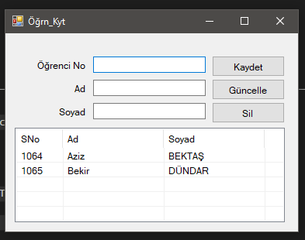 Yazdir()

End Sub

End Class

**SORU 3:**

Public Class Form1

Dim sayac As Integer = 0

Private Sub Timer1_Tick(sender As Object, e As EventArgs) Handles Timer1.Tick

sayac += 1

txtSure.Text = sayac.ToString

If sayac = 15 Then

Timer1.Stop()

MsgBox("Süre aşımı")

Me.Close()

End If

End Sub

Private Sub Button2_Click(sender As Object, e As EventArgs) Handles btnHesapla.Click

Timer1.Stop()

Dim toplam As Double = 0

Dim adet As Integer = 0

Dim sonuc As String = ""

If RadioButton1.Checked Then

For index = 0 To lstSayilar.Items.Count - 1

If Convert.ToInt32(lstSayilar.Items(index)) < 0 Then

toplam = toplam + Convert.ToInt32(lstSayilar.Items(index))

adet = adet + 1

End If

Next

sonuc = (toplam / adet).ToString()

End If

If RadioButton2.Checked Then

For index = 0 To lstSayilar.Items.Count - 1

If Convert.ToInt32(lstSayilar.Items(index)) > 0 Then

toplam = toplam + Convert.ToInt32(lstSayilar.Items(index))

adet = adet + 1

End If

Next

sonuc = (toplam / adet).ToString()

End If

If RadioButton3.Checked Then

For index = 0 To lstSayilar.Items.Count - 1

toplam = toplam + Convert.ToInt32(lstSayilar.Items(index))

adet = adet + 1

Next

Dim ortalama As Double = toplam / adet

For index = 0 To lstSayilar.Items.Count - 1

If Convert.ToInt32(lstSayilar.Items(index)) > ortalama Then

sonuc = sonuc + " " + lstSayilar.Items(index).ToString

End If

Next

End If

If RadioButton4.Checked Then

For index = 0 To lstSayilar.Items.Count - 1

toplam = toplam + Convert.ToInt32(lstSayilar.Items(index))

adet = adet + 1

Next

Dim ortalama As Double = toplam / adet

For index = 0 To lstSayilar.Items.Count - 1

If Convert.ToInt32(lstSayilar.Items(index)) < ortalama Then

sonuc = sonuc + " " + lstSayilar.Items(index).ToString

End If

Next

End If

Dim form2 As New Form2

form2.Label1.Text = "Sonuç : " + sonuc

form2.ShowDialog()

End Sub

Private Sub btnEkle_Click(sender As Object, e As EventArgs) Handles btnEkle.Click

If txtSayi.Text = "" Then

MsgBox("Sayı giriniz !")

Return

End If

lstSayilar.Items.Add(Convert.ToInt32(txtSayi.Text))

txtSayi.Text = ""

If lstSayilar.Items.Count = 10 Then

txtSayi.Enabled = False

btnEkle.Enabled = False

btnHesapla.Enabled = True

Timer1.Enabled = True

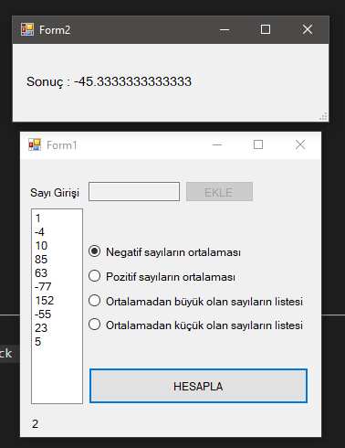 End If

End Sub

Private Sub Form1_Load(sender As Object, e As EventArgs) Handles MyBase.Load

RadioButton1.Checked = True

End Sub

End Class

**SORU 4:**

Public Class Form1

Private Sub btnCikar_Click(sender As Object, e As EventArgs) Handles btnCikar.Click

Try

Dim baslangic As Integer = Convert.ToInt32(txtBaslangicPozisyon.Text)

Dim cikarilacak As Integer = Convert.ToInt32(txtCikarilacakSayi.Text)

txtSonHal.Text = txtGirilen.Text.Substring(baslangic - 1, cikarilacak)

Catch ex As Exception

MsgBox("Hata : " + ex.Message.ToString)

End Try

End Sub

End Class

